**Exercise**

1.



2.



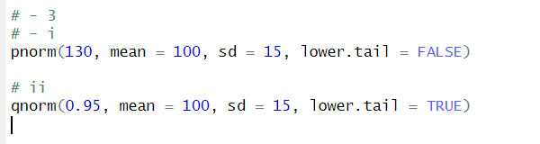3.

